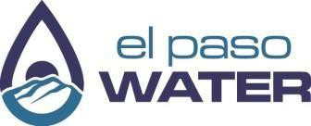

Helpful Resources for Water Damage

El Paso Water Contacts
- Emergency Hotline: 915-594-5500 (24/7)
- Online Emergency Reporting: epwater.org/report-an-emergency
- Customer Service: 915-594-5500 (Mon–Fri, 7 a.m.–6 p.m.)
- Leak Protection Program: 915-273-3999
- Leak Adjustment Requests: customer.service@epwater.org

City of El Paso: Flood Protection Information
- Contact the Division at either 915-212-1573, 915-212-1575, or 915-212-1578 for:
- Assistance and guidance about properties that are in are near a SFHA, commonly referred to as a “flood zone”

Insurance and State/Federal Assistance
- Homeowner's Insurance: Contact your insurer to check coverage and file a claim.
- FEMA: 800-621-3362 or DisasterAssistance.gov
- USDA-RD: Loans for qualifying low-income homeowners; rd.usda.gov
- 2-1-1 Texas: Dial 2-1-1 or visit 211texas.org
- Salvation Army: 1-800-725-2769 or salvationarmyusa.org
- Texas Dept. of Housing & Community Affairs: 1-800-525-0657
- Texas Department of Insurance: 1-800-578-4677
- Small Business Administration (SBA): Low-interest loans for repairs; sba.gov

